

EE6037
Top 10 Submission
Report

Mark Fitzgibbon
122319381@umail.ucc.ie

Competition Description

The competition solution selected for replication was the “IEEE-CIS Fraud Detection” competition: https://www.kaggle.com/competitions/ieee-fraud-detection/overview. The goal of this competition was to detect fraudulent transactions on a credit card, and classify the transaction as fraud or not fraud. As part of the classification process, it was undesirable to classify a non-fraudulent transaction as fraudulent.
The provided data set contained information such as type of payment method, card information, time of transaction from a set date in time, etc, as well as engineered features already supplied by the competition hosts. The data was a mixture of categorical and quantitative values. An identity data set was also included, providing information on network connection such as IP and digital signature of the browser used for the transaction. Importantly, the transactions were not grouped by card in the dataset, so it was not immediately clear from the data provide which transactions occurred with which card.

Winning Solution

The winning solution that was replicated was the first-place solution to the competition. As previously mentioned, the goal of the competition was to classify fraudulent transactions, rather than flag a card as fraudulent. The solution discovered by the winners was to use the data to group transactions which appeared to come from the same card into a user ID, or “uid”. This was the so called “magic feature” that allowed them to win the competition.
With this, the task of the competition could morph from predicting fraudulent transactions into predicting fraudulent cards. From their research on the test data set, they identified 73,838 unique cards in the data set. Of these, 73,709 have all their transactions classified as either isFraud=0 or isFraud=1. Only 129 cards, or 0.17% of cards, were a mixture of fraudulent and not fraudulent.
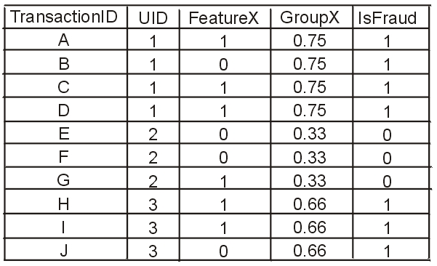
Figure 1: Example Aggregated Feature, GroupX, Based on UID (Source, Chris Deotte)
The uid feature could not be used as a new column in the prediction step of the script, as 68.2% of the cards in the test data set did not exist in the training data set. The solution was to create aggregated features from the training set, grouped by the uid, and then delete the uid from the training data. This allowed for the uid magic feature to be used, without the model being explicitly trained on it.

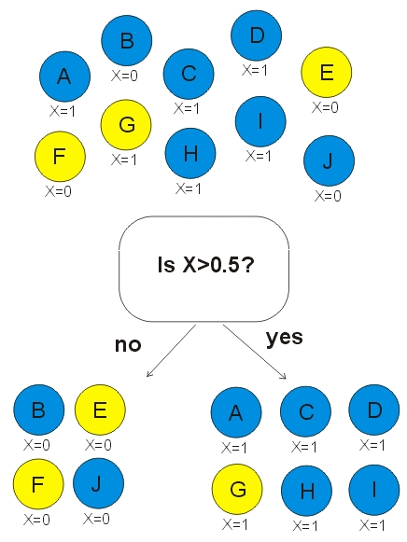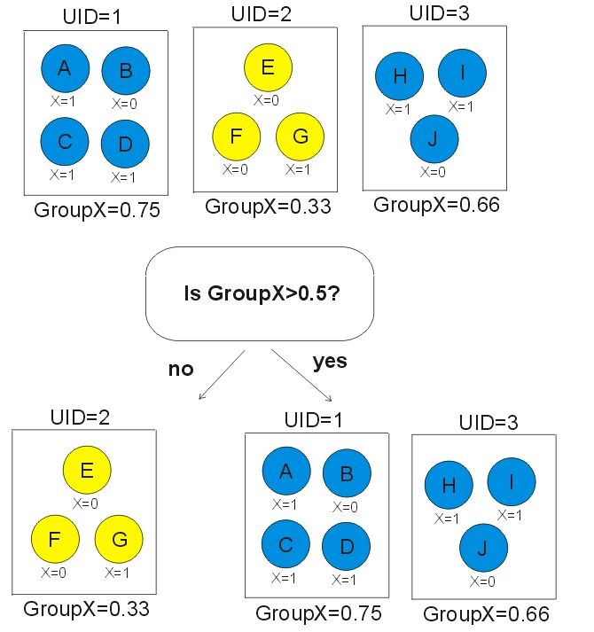
Figure 2: Single Decision Tree Classifier, Comparing Decision Based on 'X' (left) with 'GroupX' (right) Aggregated Feature utilising the UID Magic Feature. Correct Identification of Fraudulent Transactions Increases from 70% to 100% (Source, Chris Deotte)
Features used by the model were selected using a variety of different methods, such as recursive feature elimination, permutation importance, and correlation analysis, among others. These were then validated using multiple validation strategies, such as training for a few months of data, skipping a month, and then testing, as well as CV GroupKFolds using months as the group. The validation performance was then measured using AUC.
The final solution used by the winners involved an ensemble of three different models: XGB, LGBM, and CatBoost models. Each of these models did best at predicting transactions with varying levels of confidence that the uid’s identified were correct, and so the winners ensembled the three together.
Comparing with other teams in the top 10 solution range, construction of a uid magic feature appears to be a common method used by the top teams. However, what appears to set the winning solution apart was its accuracy in identifying uid’s, and so achieved the winning score.
For this laboratory, the XGBoost model was used as the base without ensembling the other two models.

Engineering Journey

The changes made to the Top 10 solution focused on attempting to improve the classification stage of the model, through manually fitting model parameters and introducing an additional model to ensemble with the original XGBoost classifier.
When the stock notebook was run, it achieved a Private Leaderboard score of 0.932177, verifying that out of the box this model achieved the competition-winning score. The first changes made to the classifier involved attempting to overfit the model to the dataset. This was done by increasing the max _depth of the classifier trees from 12 to 15, allowing the trees to become more specific in their decisions, as well as increasing the learning rate from 0.02 to 0.04. Instead of becoming overfit however, the model actually improved, achieving a score of 0.933039, as well as a better public leaderboard score. This suggests that the original classifier was underfit, and that the hyperparameters were not properly optimised.
Next the local validation model used for testing the engineered features effect on the model performance was modified. The local validation split the training data into train and test sub units, so that the model’s predictions can be verified on data with known fraud identifiers. First the split between the train and test data was changed from 75% train to 60 train, which resulted in a minor decrease in LB performance, as seen between Version 4 and Version 5 submissions. Next the local validation classifier parameters were changed to match those used for the Version 4 submission, and hence Version 7 saw a further deterioration in score. This is interesting, as the local validation should in theory have had no effect on the final Kaggle submission, which uses a separately trained classifier as its model.
The next potential improvement tested was the introduction of a CatBoost classifier to ensemble with the XGBoost. This classifier was set to have a max depth of half that of the XGBoost, with the goal of the shallower trees to capture patterns in the data which might be different than those captured by the deeper XGBoost. The two classifiers were weighted 50-50 at ensembling. The result, as seen in Version 9, was a further reduction in the score of the model, with a rough decrease of 0.0008.
The next test was to increase the influence of the CatBoost at the ensemble step, to see if that would improve its effect on the model. Its weighting was first increased to 70%, and then to 90%, of the final prediction output. From Versions 10 and 11 of the submissions, the performance of the model is seen to be further deteriorating, as far down as 0.925033. These tests suggest that the inclusion of the CatBoost classifier was a poor addition to the original XGBoost, as the model achieved a higher score prior to its introduction.
The final major test carried out on the model was the removal of the “magic feature”, the uid, and its influence on the engineered features. This reduced the private leaderboard score to 0.913257, as seen in Version 12, the lowest score seen yet. This reinforced the winners’ argument that the key difference maker in this competition was this “magic feature”. However, the feature engineering in the notebook proved to not be over-reliant on the magic feature, with the model continuing to score well, despite the uid not being used.
Subsequent versions submitted consisted of small tuning changes to the classifiers’ hyperparameters, however since they resulted in continually worsening scores, they won’t be discussed in detail.
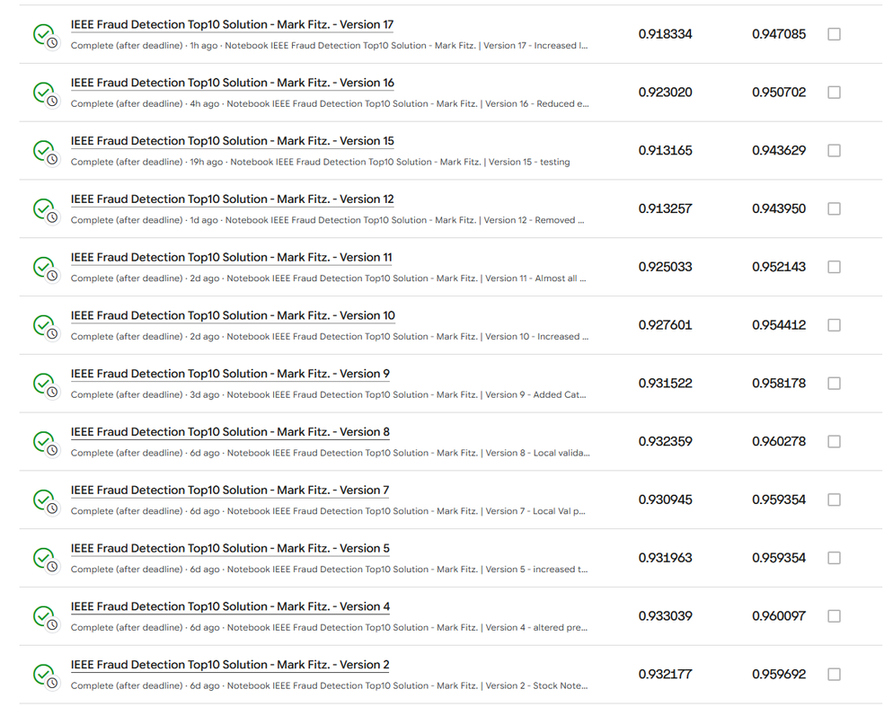
Figure 3: Public and Private Leaderboard Scores Achieved by Altering the Top10 Solution

Conclusion

This project investigated a winning solution to the IEEE-CIS fraud detection competition, in order to understand the engineering decisions that resulted in it winning the competition, and testing potential improvements to the classification models.
The initial notebook scored a private leaderboard score of 0.932177, which served as a baseline for future tests to compare against. The most successful test involved tuning the hyperparameters of the classifier model, with increasing the max tree depth and learning rate improving the score.
The introduction of a CatBoost classifier and the tuning of the ensemble weights failed to produce an improvement in the score. This showed that increasing the amount of complexity and learning performed in a model does not necessarily improve the model’s performance.
The greatest insight into the winning solution came when the uid “magic feature” was removed from the feature engineering process. The score achieved by the model dropped to 0.913257, making this change the single most consequential edit to the model’s performance. It reinforced the fact that the winning solution’s key differentiating factor was their high-accuracy in determining card uids, as opposed to other competition entries.
Overall, this report and the experiments performed highlighted the importance of feature engineering, tuning model hyperparameters and the aggregation of feature trends into a “magic feature”.

